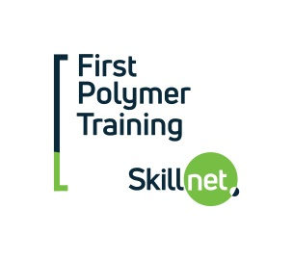

PROGRAMME TITLE: B. Engineering in Polymer Processing
LEVEL: 7
DURATION: 2 YEARS- PART-TIME- PRIMARILY ONLINE (Sept – May each year).
ENTRY REQUIREMENTS: Level 6 trade/engineering qualification plus at least 5 years’ experience in industry. For those who do not have the required entry qualification RPL (Recognition of Prior Learning) may apply.
FULL FEES: €3400 per year or €1700 per semester
FUNDING: 30% available via your employer from First Polymer Training. €2380 total cost per year or €1190 per semester. If you decide to apply and are accepted please let us know (before paying a deposit) if you wish to avail of funding.
CONTACT: Catherine Collins, First Polymer Training Tel: 090 6471223 or c.collins@firstpolymer.com
PROGRAMME DETAILS: The subjects covered in this 2 year long programme are
Medical Device Manufacturing ( 5 Ects), Six Sigma 1– Intro to Lean Sigma Quality ( 5 Ects), Sigma 2 - Statistical Control (5 Ects), Polymer Processing (5 Ects), Plastic Part Design (10 Ects), Project (Level 7- 5 Ects), Mathematics (5 Ects), Polymer Tooling : Design and Manufacturing Techniques (5 Ects), Control Systems (10 Ects) and Materials for the Polymer Industry ( 5 Ects).
*Ects are credits
Online lectures are generally delivered 3 evenings approx. per week. This programme also requires attendance on a number of practical days per semester (4 approx.) (normally Fridays – most of these days will happen in Sligo with at least 1 day per year in Athlone) and there will be an induction day in September at the start of Year 1, in IT Sligo to allow candidates to familiarise themselves with accessing online lectures and meet the course co-ordinator, lecturers and fellow students. If a student misses any live lectures, they are all recorded and can be accessed later and are available for the full year for students to review. Exams are scheduled in January and again in May and students have a choice of any one of the following locations- Sligo/Dublin/Cork.

The deadline for applications is usually late August but it is advisable to apply well in advance of this as the programme has been previously oversubscribed.
Click below for more information or to apply:
http://itsligo.ie/courses/beng-in-polymer-processing/

Course Co-ordinator IT Sligo: David Mulligan- Mulligan.David2@itsligo.ie Tel: 0719155220

